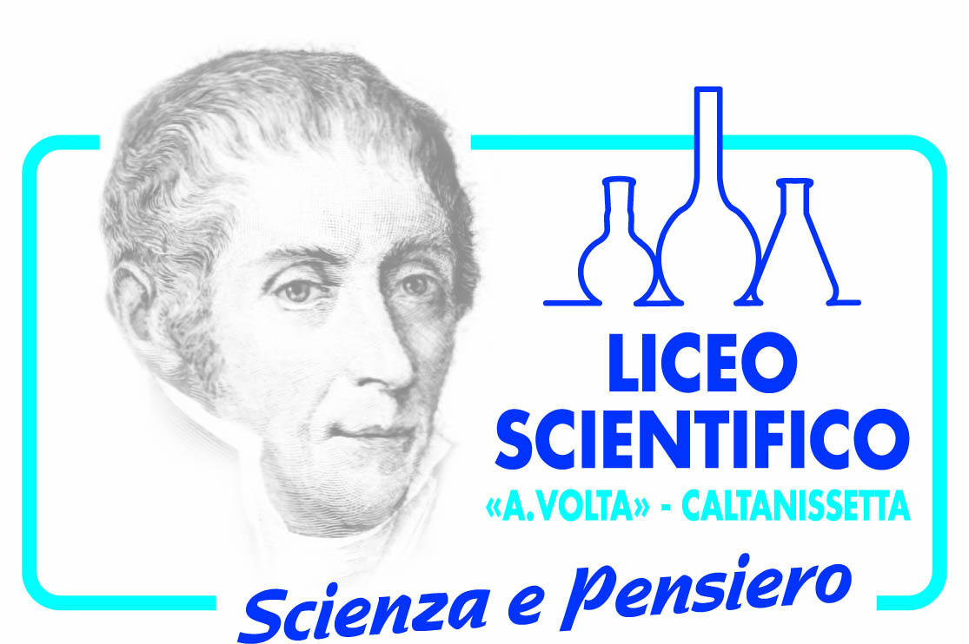

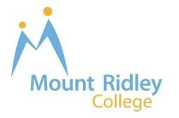**Sister-School Agreement**

**Mount Ridley P-12 College and Liceo Scientifica ‘A.Volta’ Caltanissetta, Italy**

Mount Ridley P-12 College, Australia and Liceo Scientifica ‘A.Volta’ Caltanissetta, Italy, hereby form an affirmation and Sister-School Agreement to promote understanding, friendship, education and international exchange programs between our respective organisations.

The purpose of this collaborative agreement is to:

1. broaden and strengthen the global educational programs at both Colleges;

2. contribute to the development of a student exchange program; and

3. develop staff professional learning opportunities between Mount Ridley P-12 College and Liceo Scientifica ‘A.Volta’ Caltanissetta.

This agreement is based on the strong belief that global education is an essential investment for our students and that, through this partnership, both schools will foster innovative educational and cultural exchange programs that are accessible for our students, staff and wider community of both schools.

**Sister-School activities will include:**

• exchanges of information including curriculum, school policy and school events;

• exchanges of teaching resources, course materials and teaching strategies;

• exchanges of student work through means such as email, letters, photos and College newsletters to promote mutual understanding;

• student and staff exchange programs aimed at providing the opportunity to study, work and live in the sister school community;

• the delivery of curriculum programs that involve a range of subject areas, such as

English, Italian and Arts through ICT-mediated communication; and

• the provision of a staff professional development program that focuses on a range of areas including literacy, numeracy, economics, science, global education and student engagement.

Signed in the spirit of international understanding,





Mr. Lino Pagano Mr. Giuseppe Bruccheri

**College Principal Principal**

**Mount Ridley P-12 College Liceo Scientifico ‘A.Volta’**

**2-30 Hampton Street, Craigieburn, Via N. Martoglio, 1 Caltanisetta,**

**Australia Italy**

Dated this day of 27/02/2013